**Lecture 1 : what is rest api**

**Rest : stand for** representational state transfer

**Api :** application programming interface

Will learn :-

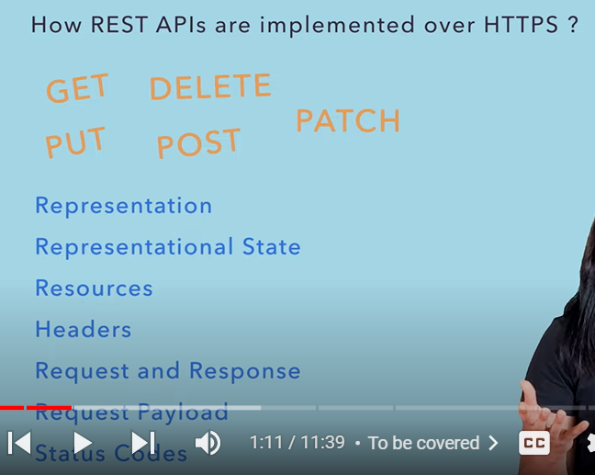

**REST is a standard and rest api can be implemented over different protocols**

REST APIs use the HTTP protocol to send and receive data.

**In most case rest api can be implemented over https and there are diff https method which make this possible**

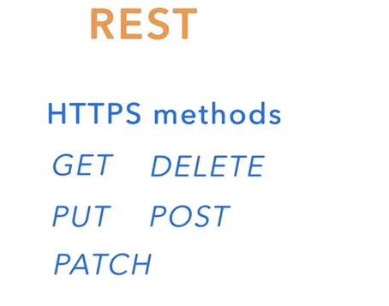

**REST :**  is all about transferring data from one layer of system to another layer like client and server or between two server

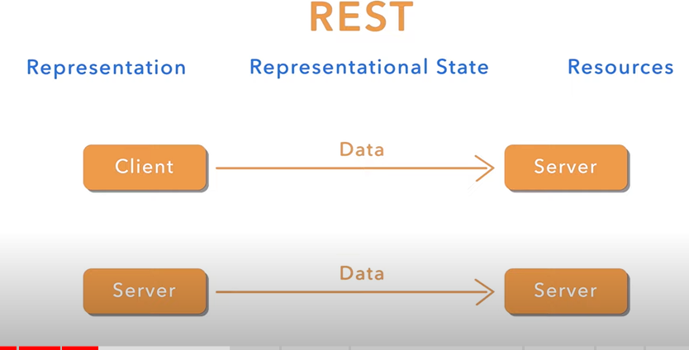

The data we are taking here is actually the resource

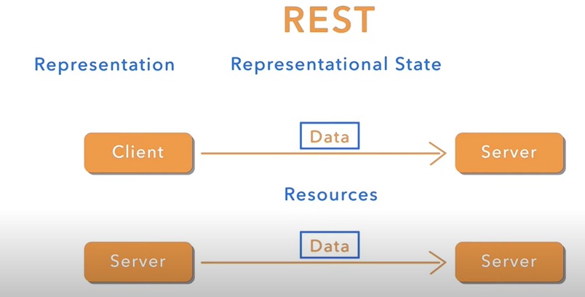

See it

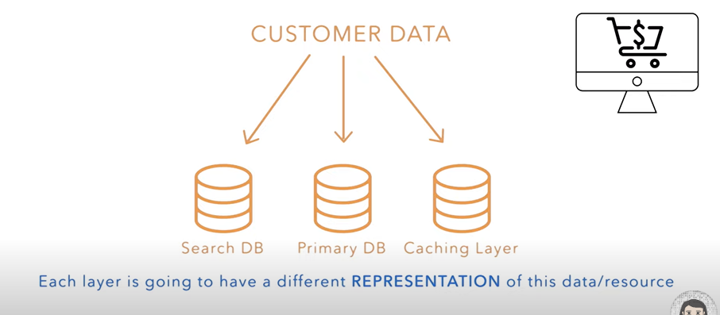

Data is referred as resource like customer data is resource and these resource are stored in different storage. These resources also need to transfer from one layer to another

**State of resource or data may be diff in server and client**

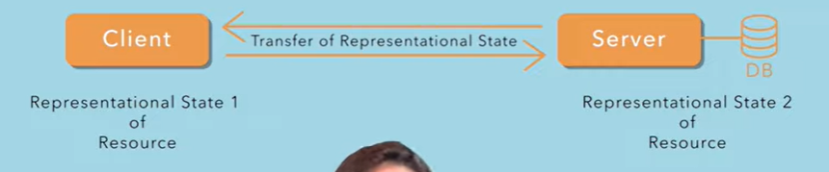

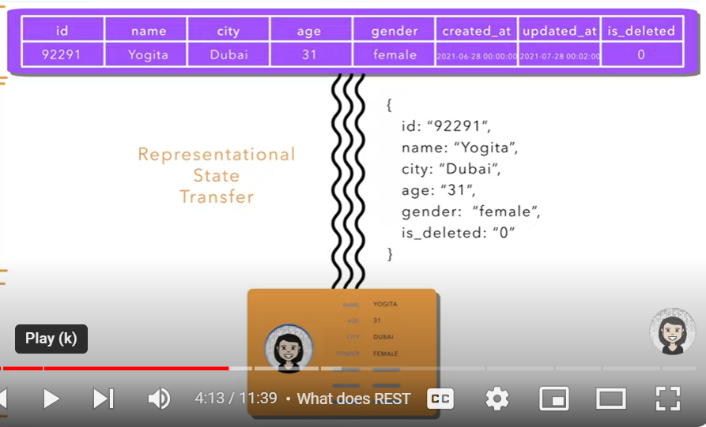

**So rest is all about**

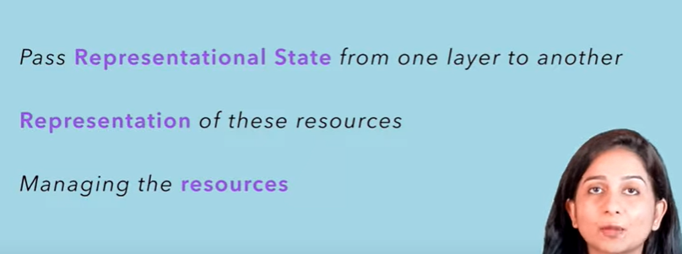

**Note :**

**Any rest api implemented over http protocol will be composed of some URI(uniform resource identifier) which point to some resource in d/b**

A URI is **a Universal Resource Identifier**, identifying where a specific resource can be found, such as a page or a document.

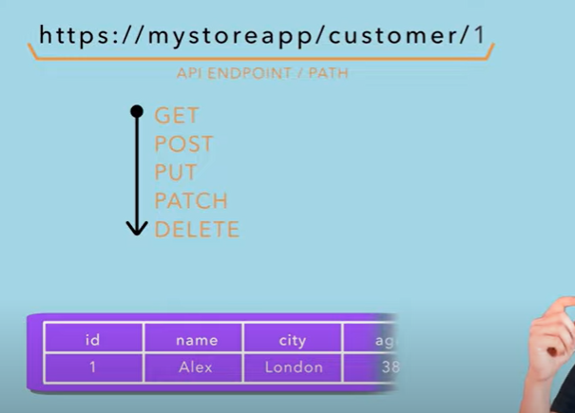

**There are different method which can interact with this resource**

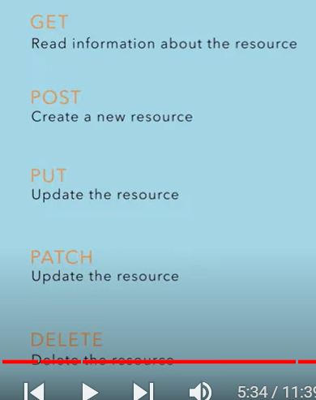



**2- is path parameter. So changing path parameter will change the resource that we are pointing**

**Note:**

There can also be URI without path parameter. It will list all customer

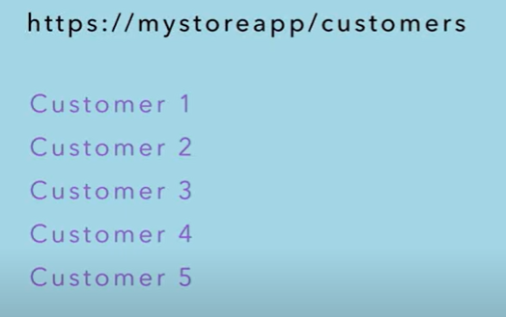

**Path Parameter:---**variable in a URI path that help in pointing towards specific resource

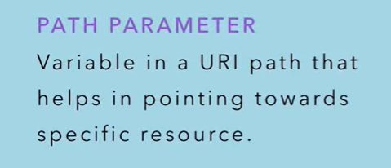

**Find all the customer whose name contain string abc**

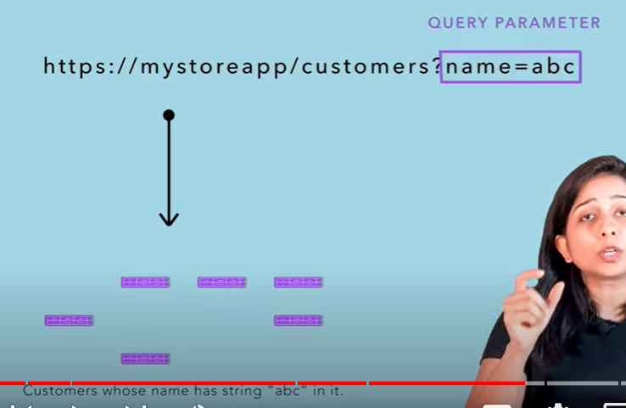

**Difference between path and query parameter**

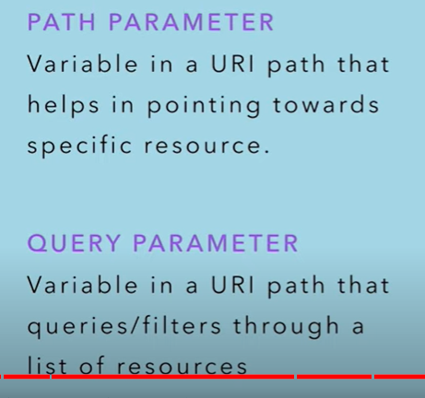

**Note :**

**Put, post, update can modify the state of the resource so for this we need to send request payload**

**With the request or api will send some data which we want to update**

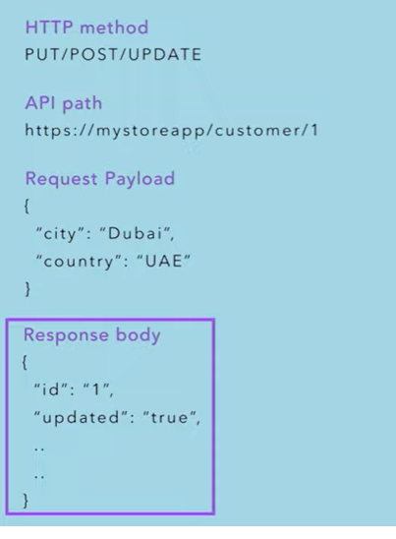

**With every rest api , implemented over http protocol**

**Note :**

With every restapi implemented over http protocol will get some **http status code that**  try to tell us to the api about the response we got.

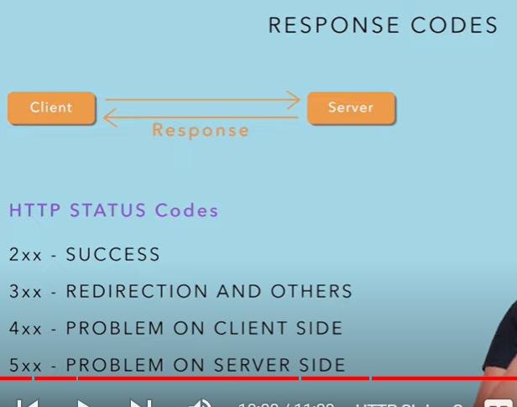

**Http headers** : are just like the request in request payload

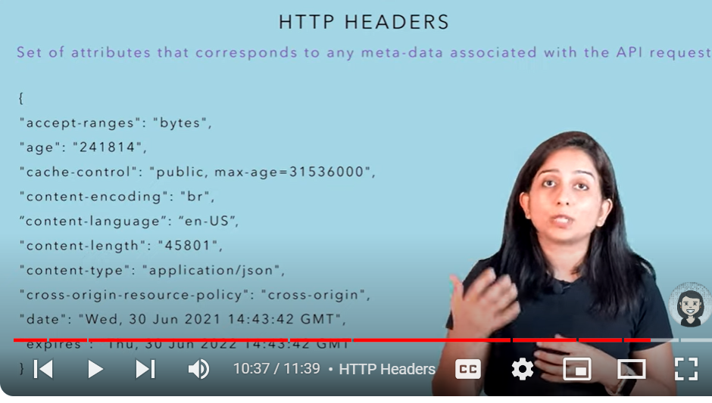

Lecture 2 : what is http post api

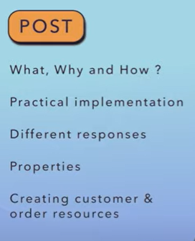

**POST** : method is use to create a resource

Let create a post resource this is how uri look like some header is also there

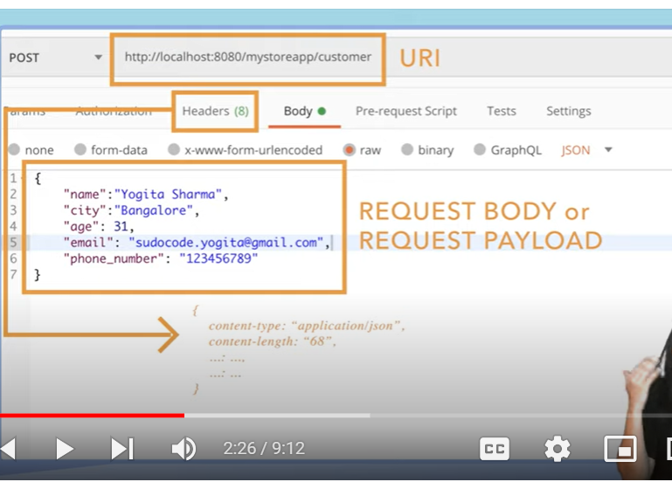

**Response code 201 means : resource has been created**

**Sometime we post data for processing but don’t want any response**

**204 means : no**  content means your request has been accepted , processing has been done but response is empty

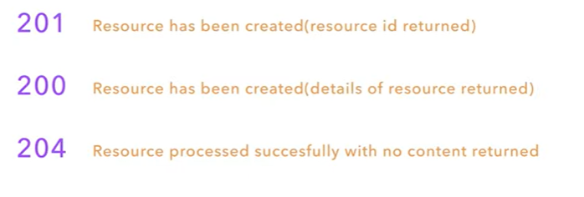

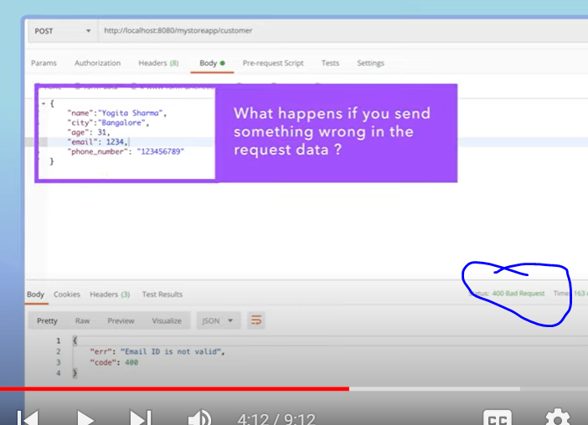

**Note :**  what happens if we send something wrong to the data like invalid mail

In that case server will return **400**

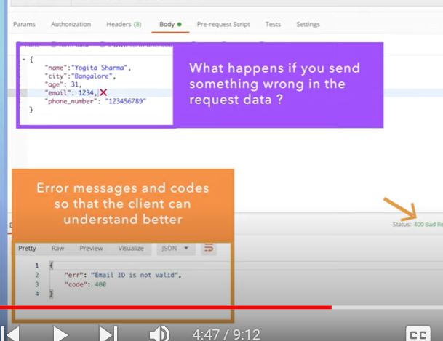

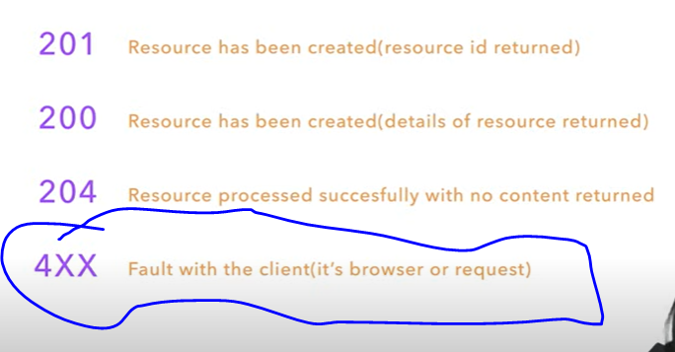

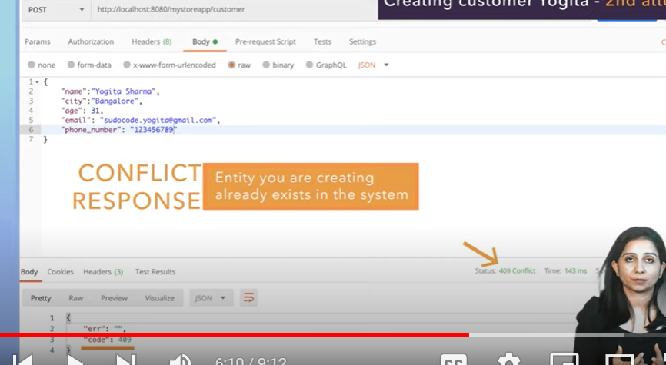

409 : submitting same request again then will get conflict response

A 409 status code is used to indicate a conflict with the current state of a resource, such as when trying to create or update a resource that already exists or has conflicting information.

**Idempotent :**

**If** we send request multiple times the responses always going to be same

**POST request is not idempotent**

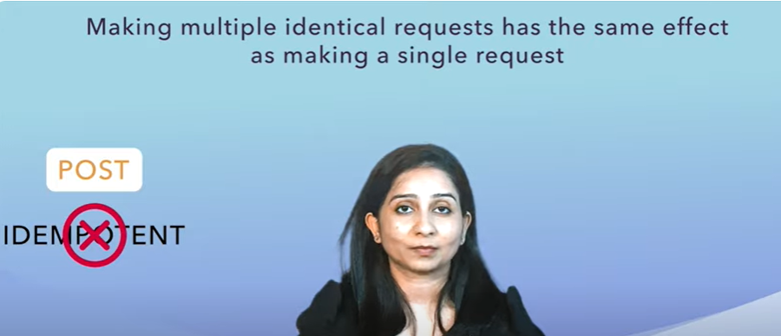

**In case of post first time it will create but second time it will give error 409 that’s means post request is not idempotent**

**NOTE:**

GET request is idempotent since will get same response again and again

**Requirement :**

**Want to create order for this customer**

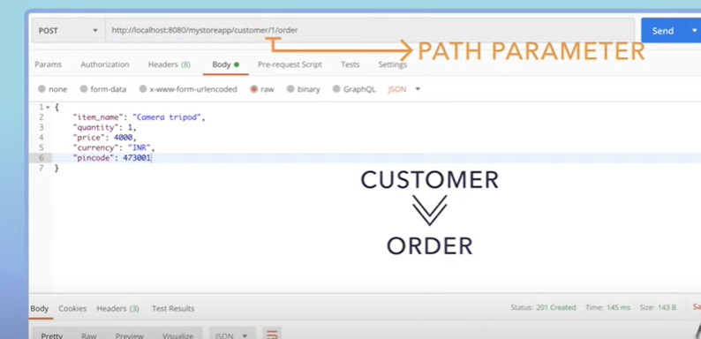

**We**  are trying to create an order for customer 1

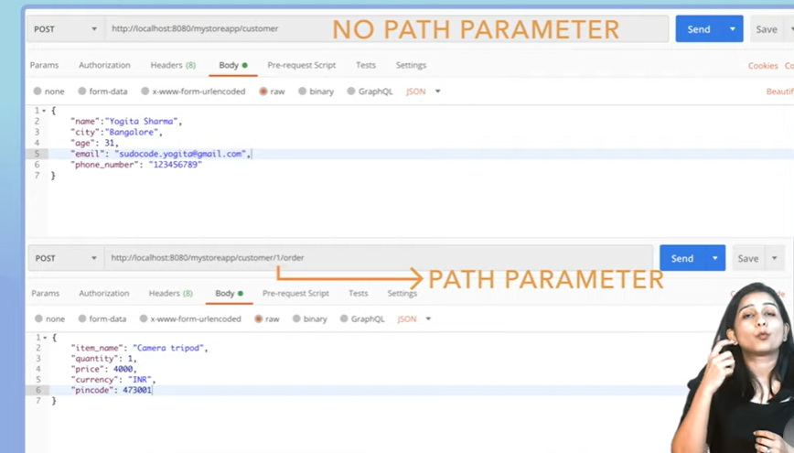

Note : we can use path parameter in post uri

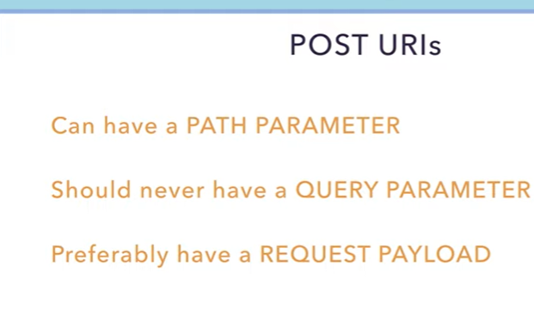

Lecture -3 ( get http method)

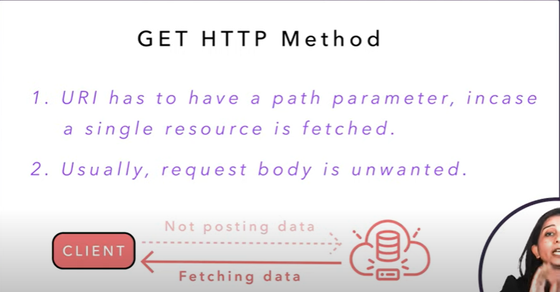

This is how we fetch one customer using get api

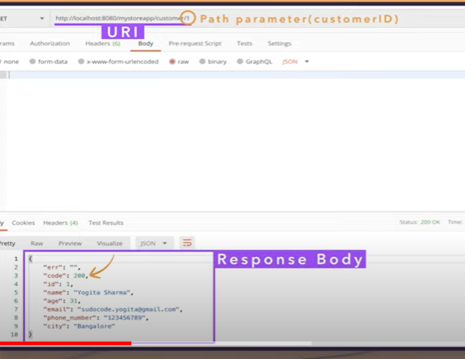

Note

Want to fetch all customer :- we cannot fetch all customer in one api response that’s why we use pagination or limits

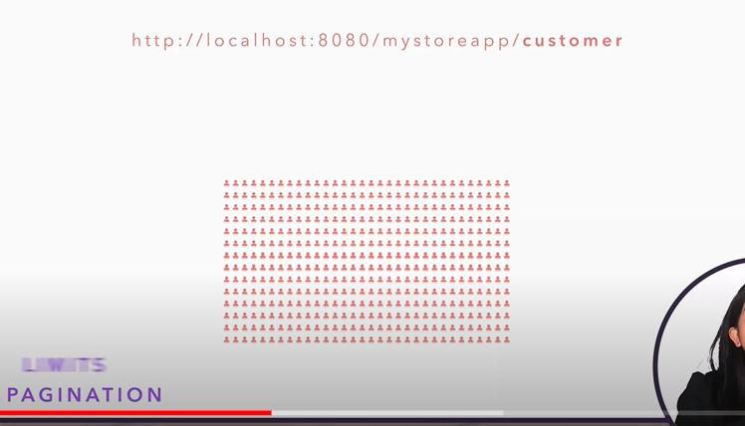

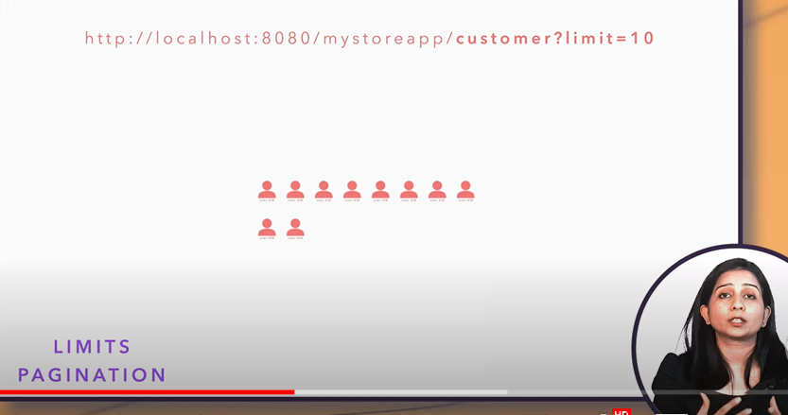

That’s why we use ?limit=10

**Offset : tell**  from which counting response has to be return

**If I say offset is 0 and limit is 10 that’s means I want first 10 customer resource**

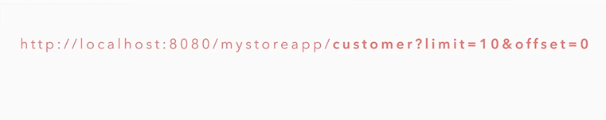

Requirement



We can use query paratmeter ?name=”abc”



All the get response

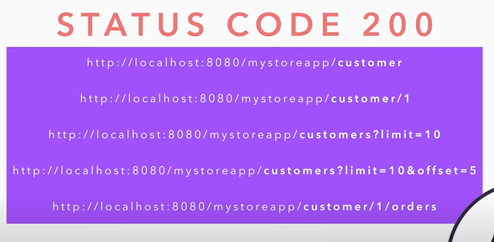

Now will see what error can be happen

If customer id is not present

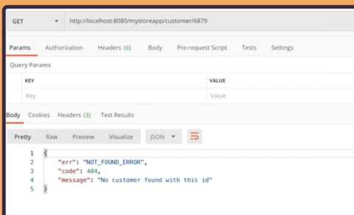

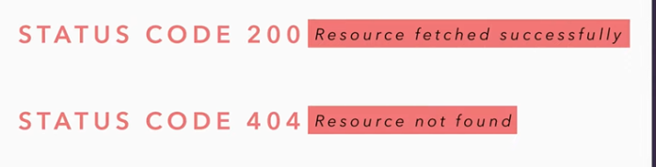

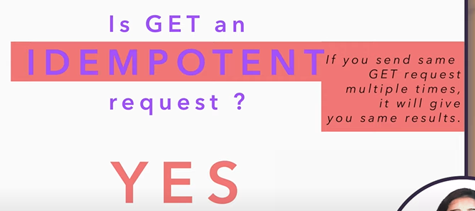

Security in terms of get request is very imp.

Tutorial 4 - put/patch

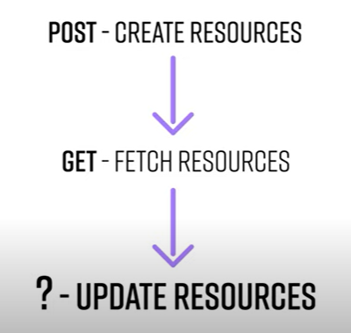



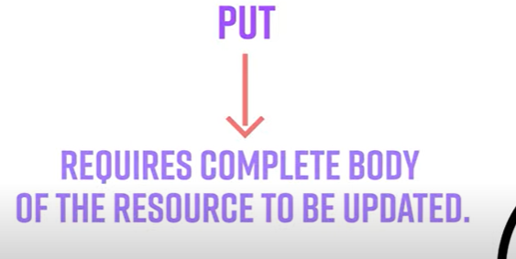

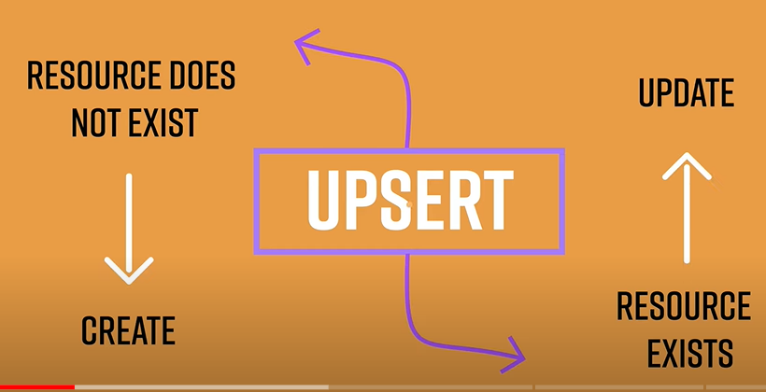

Put : use for both create and update

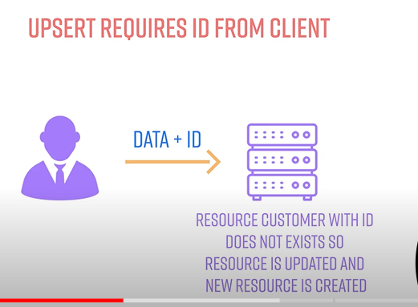

As a response will get whole object

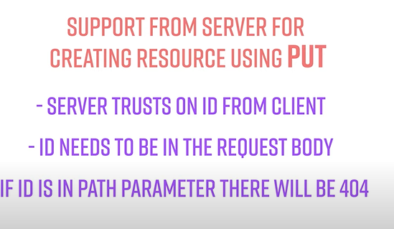

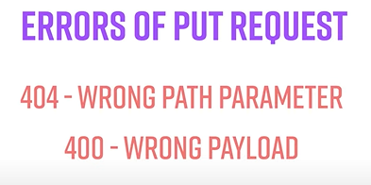

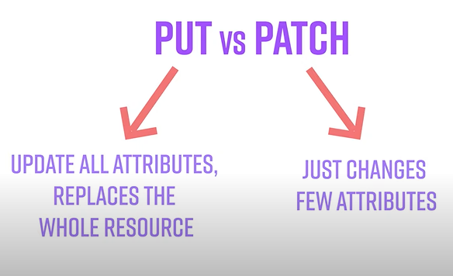

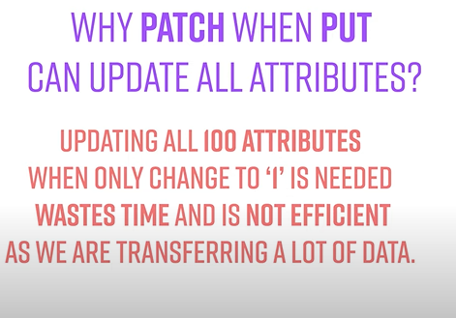

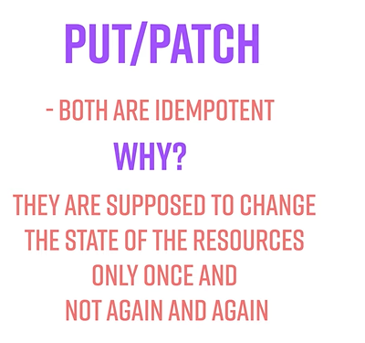

Tutorial 5 ☺ delete rest api

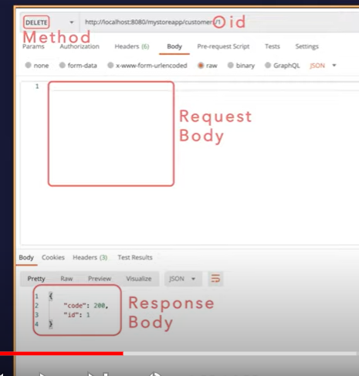

Two ways we can delete

Complete entry deleted

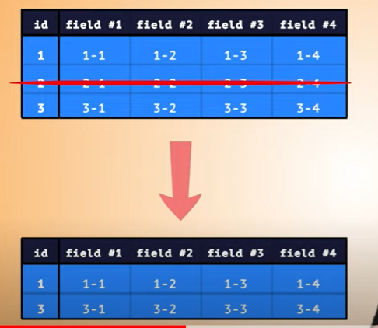

2- soft delete

Soft delete is a technique used in databases to mark records as "deleted" without actually removing them from the database. Instead of permanently deleting data, soft delete adds a flag or indicator to the record to signify that it has been logically removed from the system. This approach is often used to maintain data integrity and enable easy recovery of deleted records if needed. Here's how soft delete typically works:

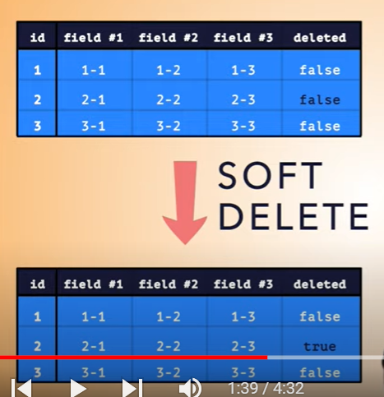

How to check delete has been successful

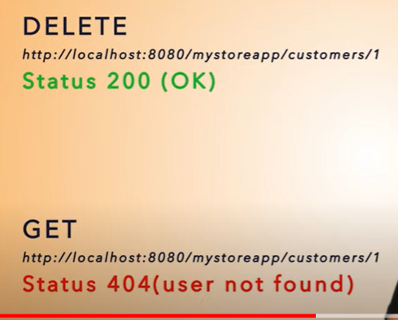

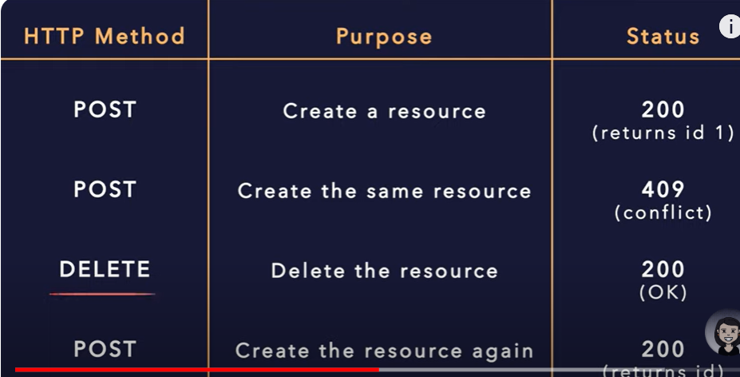

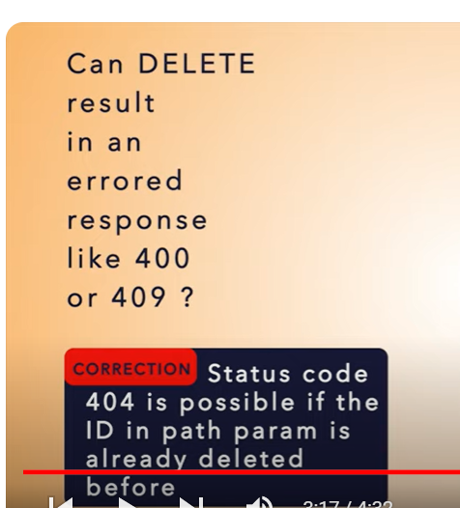

Tutorial 6

**How to design API that display and filter through millions of products.REST API Filters & Pagination**

Lets start with filtering

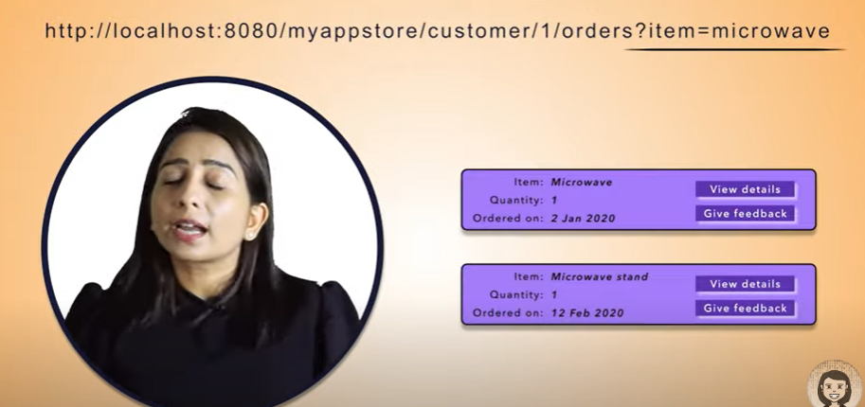

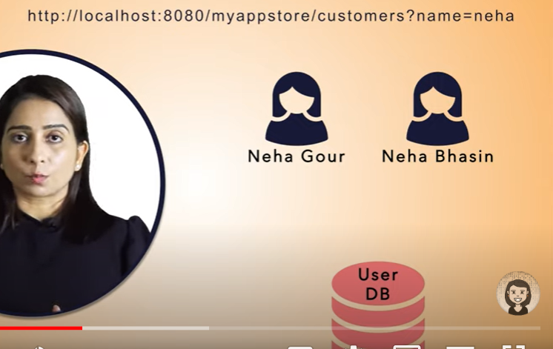

So this is how filter works



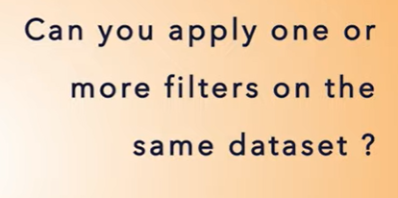

Yes we can

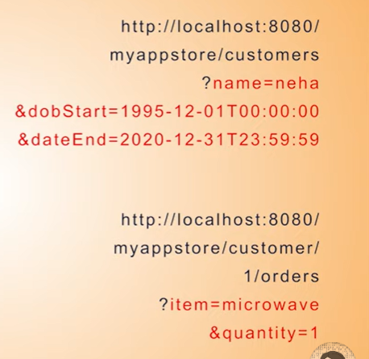

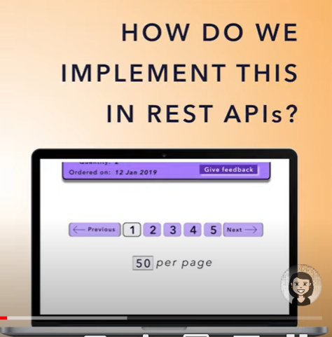

This is one way in frontend side

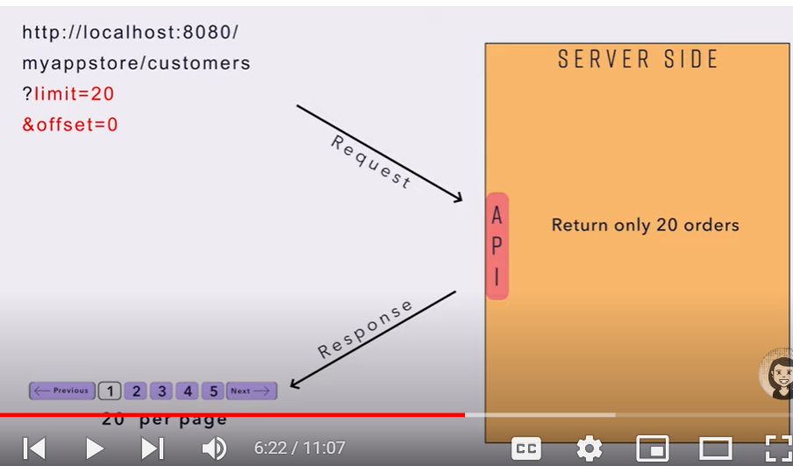

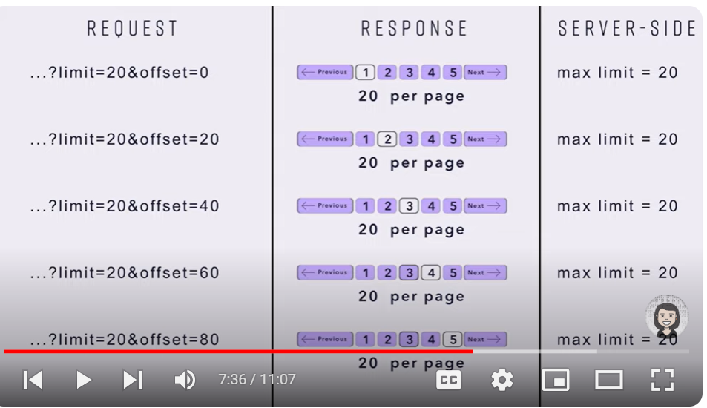

Note :

We can apply both filter and pagination

Tutorial 7

# How REST APIs support upload of huge data and long running processes | Asynchronous REST API

# 

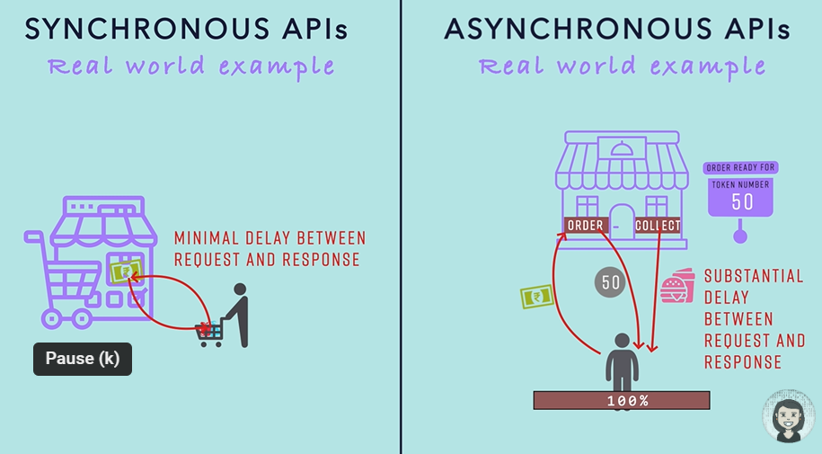

Want to upload huge amount of data will get 202 response :---- means accepted your response

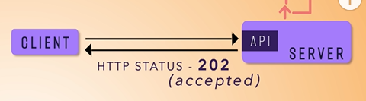

Will get token in header that we can check whether it is completed or failed

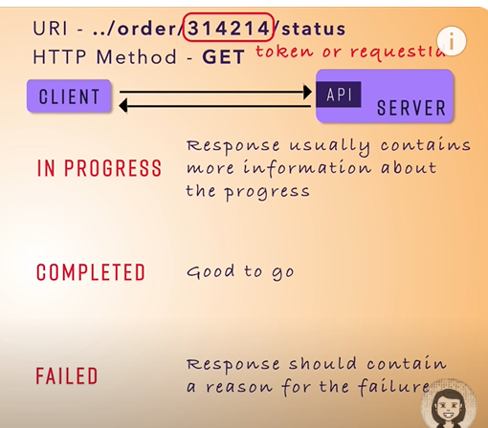

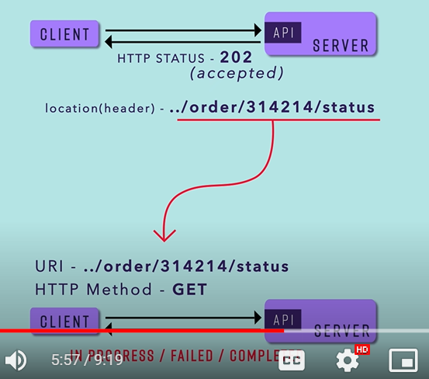

303 ----data has been uploaded there

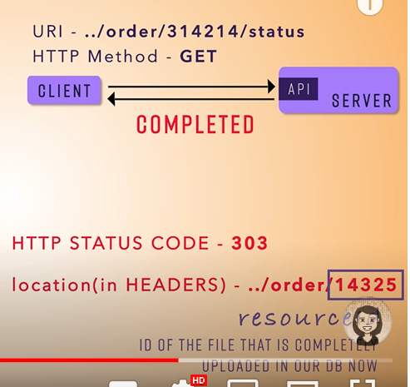

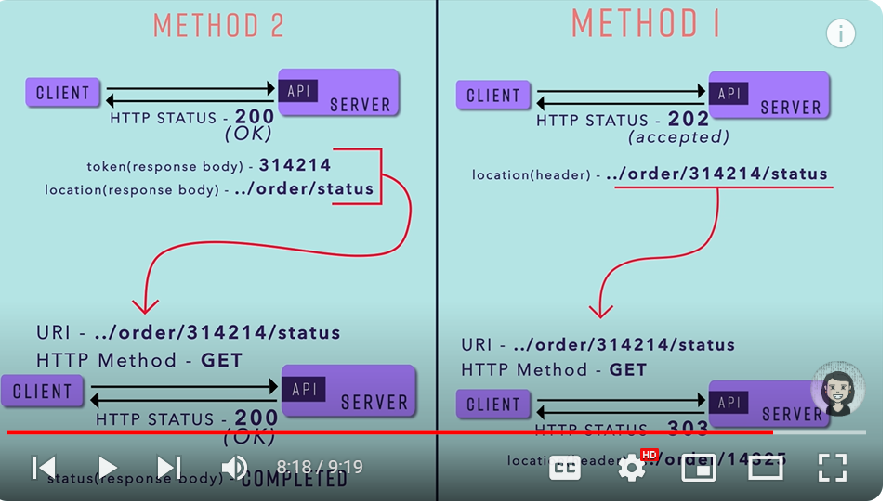

Note : we can send in response body also whatever we are sending in headers.

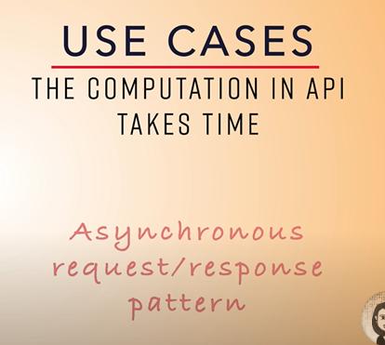

Tutorial 8

# What are the different API rate limiting methods needed while designing large scale systems & why?

# 

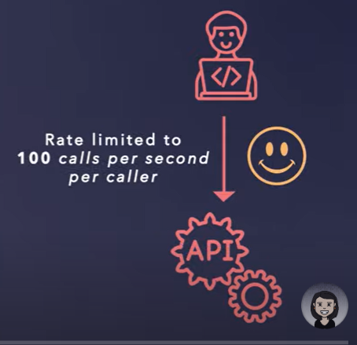

429

A 429 response is not technically an error — it's a response from a server, application programming interface (API), or plugin that tells the client application to stop sending requests because they simply don't have enough resources to accept it at this time.

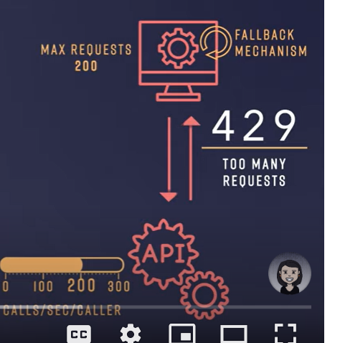

A 504 Gateway Timeout error indicates that the web server is waiting too long to respond from another server and “timing out.” There can be many reasons for this timeout: the other server is not functioning properly, overloaded, or down.

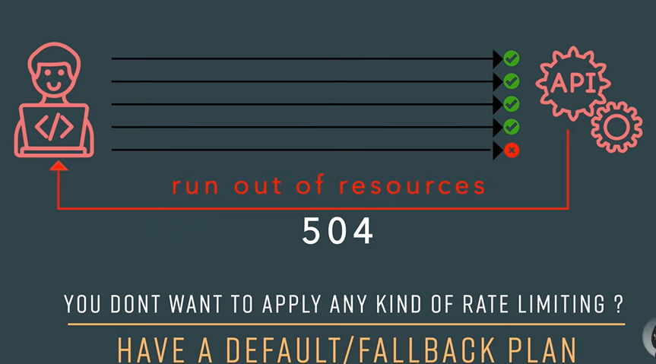

Tutorial 9 :

# How to use headers in REST APIs? Different types of headers, how and where to use?

# 

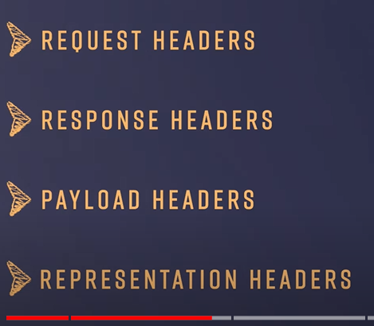

Client send key value pair

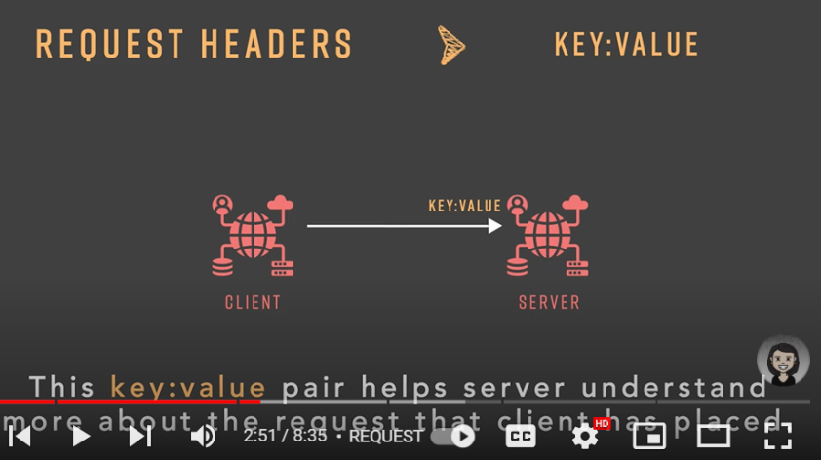

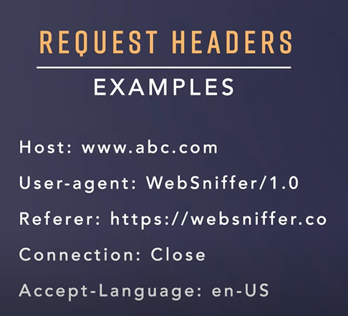

Response Header

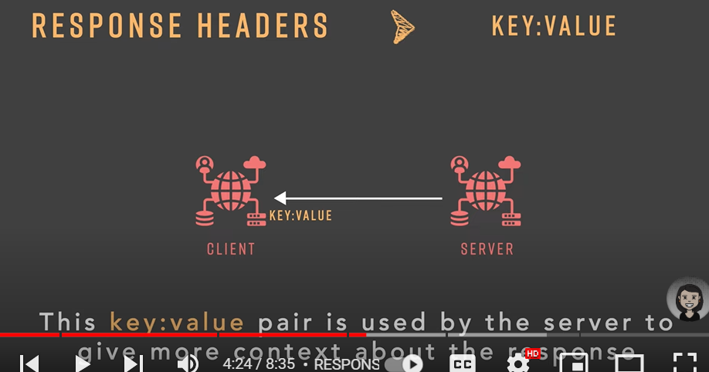

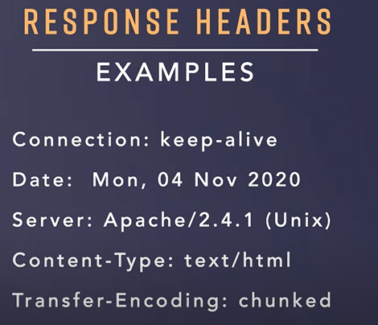

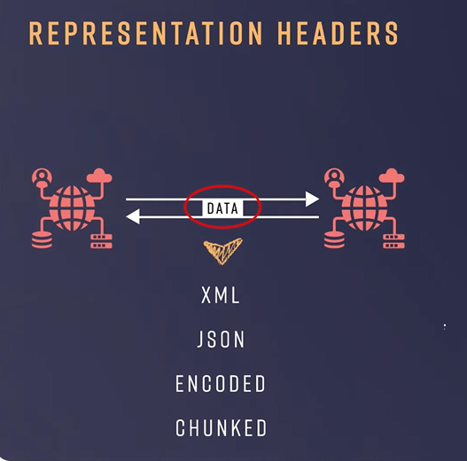

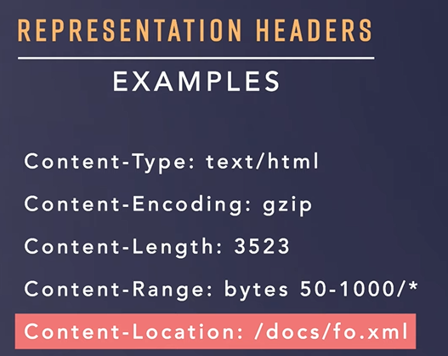

Custom header : authorization